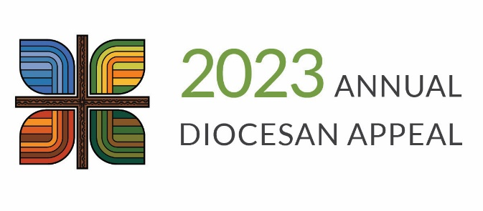

Transmittal Report Form

Instructions for Processing

Contribution Cards

*Place each check on top of the contribution card.*

*\*PLEASE DO NOT SEPARATE THE CHECKS FROM THE CONTRIBUTION CARDS AND DO NOT STAPLE THE CHECKS TO THE CARDS.*

1. Separate the completed contribution cards into two groups:

Group A: Cards with a payment.

Group B: Cards without a payment and have committed to give.

1. Process the cards by performing the following steps:
2. For group A and B: You will need to verify that the information on the card matches the attached payment.

Section 1. I CHOOSE TO GIVE

Verify that “MONTHLY” or “ONE-TIME” box is checked. If MONTHLY is checked, either “Until I choose to stop” or “10 months” should be checked. `

Section 2. PAYMENT DETAILS

If they are choosing to give monthly, verify that we should or should not send payment reminder.

Verify that “Payment enclosed” is filled out and that the check number and date and Diocesan ID are filled in, if applicable.

1. Confirm that all checks are signed, dated, and made payable to “Diocese of Des Moines.” If a check is made out to your parish, endorse the check over to the Diocese. Any checks or monies deposited by the parish for ADA should be reissued in the form of a parish check made out to the Diocese of Des Moines with “ADA” in the memo.

*NOTE: If the parish deposits a check for the ADA, and then writes a check to the Diocese, the parish will need to include this contribution in the year-end statements, as the parish is the receiving organization. If the parish forwards a check directly to the Diocese from a donor, do not include that gift in the parish’s contribution records or provide other acknowledgments to donors – the Stewardship Office will do this.*

1. On any contribution card which has not been pre-addressed, please verify the parishioner information: Diocesan ID, Correct Name, Address, City, State, and ZIP Code, and that information is legible.
2. Add the Diocesan constituent ID number to any contribution card that is not pre-addressed. The Diocesan constituent ID can be found by looking in ParishSOFT. The Diocesan ID can be found in the family record as “Diocesan ID” or on the family list screen as the “sDiocesanID.”
3. In preparation for completing the Weekly Transmittal Report Form, tally the information necessary for all of the contribution cards.
4. Complete a Weekly Transmittal Report form (see enclosed copy). Keep a photocopy for the parish records and send the original to the Diocese with the contribution cards and checks.
5. Place the payments on top of each contribution card. Please do not staple or paperclip the checks to the contribution card.
6. Place a separate rubber band around Group A cards and checks and Group B cards and checks.
7. Place all completed contribution cards and checks in the white transmittal envelope provided.
8. Place the appropriate U.S. postage and the return address of the parish on the white transmittal envelope and mail it to the Diocesan Finance Office.

*If you have any questions about this process, please contact Laura Hofstrand at* [*lhofstrand@dmdiocese.org*](mailto:lhofstrand@dmdiocese.org) *or 515-237-5009*